Manila Water Company
FUNCTIONAL SPECIFICATION – Enhancement
DID_M2C_166
Bill Print Email Functionality.
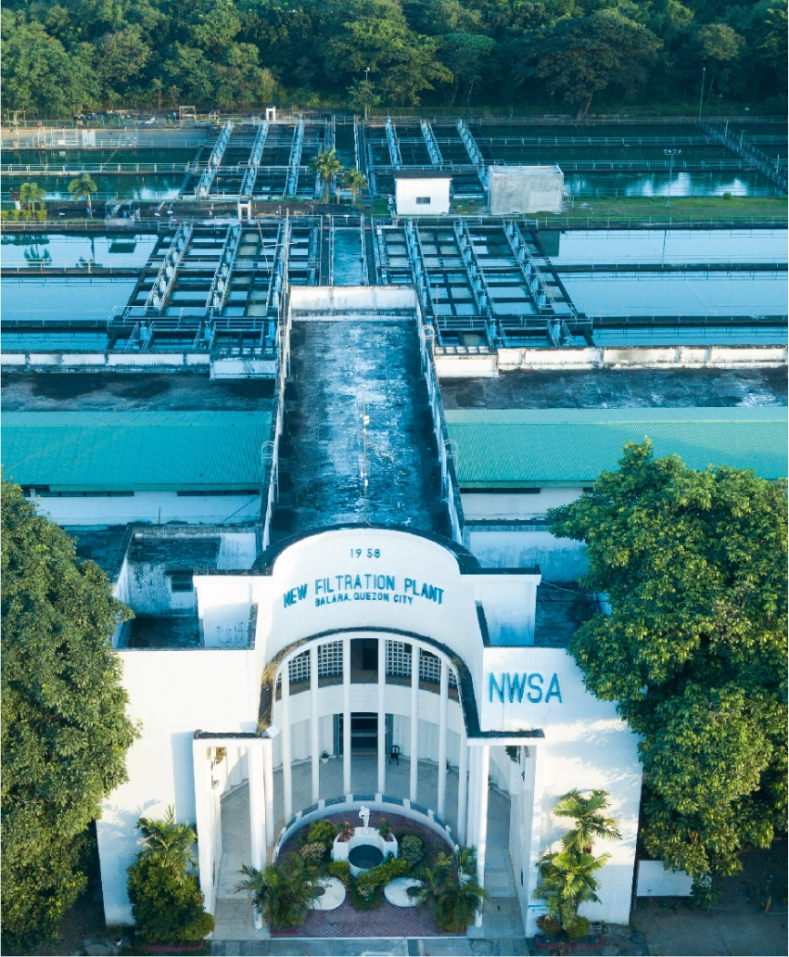

Customer NameDocument Title





Contents
1.1 Document Log 4
1.2 Integration, Document Reference 4
2 Functional Description 4
2.1 Assumptions 5
2.2 Processing Type 5
2.3 Output Type 5
2.4 Functional Design 5
2.5 Security / Authorization Requirements 5
2.5.1 Definition 5
2.5.2 Defined Fields 5
2.5.3 Procedure 5
2.6 Process Flow Diagram 5
2.7 SAP Transaction 5
2.8 Form Layout 5
2.9 Printer Requirements 6
2.10 Legal Requirements 6
2.11 Form Fields 6
2.11.1 Main Heading 6
2.11.2 Sub Heading 6
2.11.3 Totaling 6
2.11.4 Sorting 7
2.11.5 Page Breaks 7
2.11.6 Stationery 7
2.11.7 Logo(s) 7
2.12 Bar Coding Requirements 7
2.13 Email Requirements 7
2.14 Existing Sample Forms 7
3 Assumptions in Functional Design 7
4 Open Issues in Functional Design 7
5 Business Test Conditions 8
6 Related Documentation 8
Document Organization
This section provides details about this document, previous version(s) of this document and the document(s) referred.

Document Log
Following table mentions the version changes and the processer(s):
Version | Status | Date | Version Created by (Name/E-Mail/Company) | Role | Comments
0.1 | Draft | January 14, 2025 | Harshvardhan.Rathore@email.com | Author | First Draft.
0.2 | ​​Ready for Review​ | ​​Jan 17 2025​ | Roopali Sharma  roopali.sharma02@sap.com  Mohanrangan  Mohanrangan.rangarajan@sap.com | ​​Reviewer​ | Technical Review
1.0 | Final | February 12, 2025 | Harshvardhan.Rathore@email.com | Author | Additional Points from MWC incorporated.

Integration, Document Reference

S. No. | Referred Document Name | Referred Document Version | Referred Document URL (Optional)
1 | Bill Print FS for R&B | V0.3 | To Be updated
2 | Bill Print FS for OSB | V0.3 | To Be updated

The documents listed here are explicitly not part of this Functional Specification. They are not automatically accepted together with this Specification, but may be subject to a separate customer/SAP acceptance.

Functional Description

This is a soft copy of the SAP generated invoices are to be sent out to the end customer’s email address maintained in at the Business Partner Level.
The functionality will be triggered after the Invoice batch program is executed so that all printed invoices are then sent out as PDF attachment over email.

Assumptions
For all Customers, the email address is mandatorily maintained at the Business Partner Communication Subsection of the Address Tab. 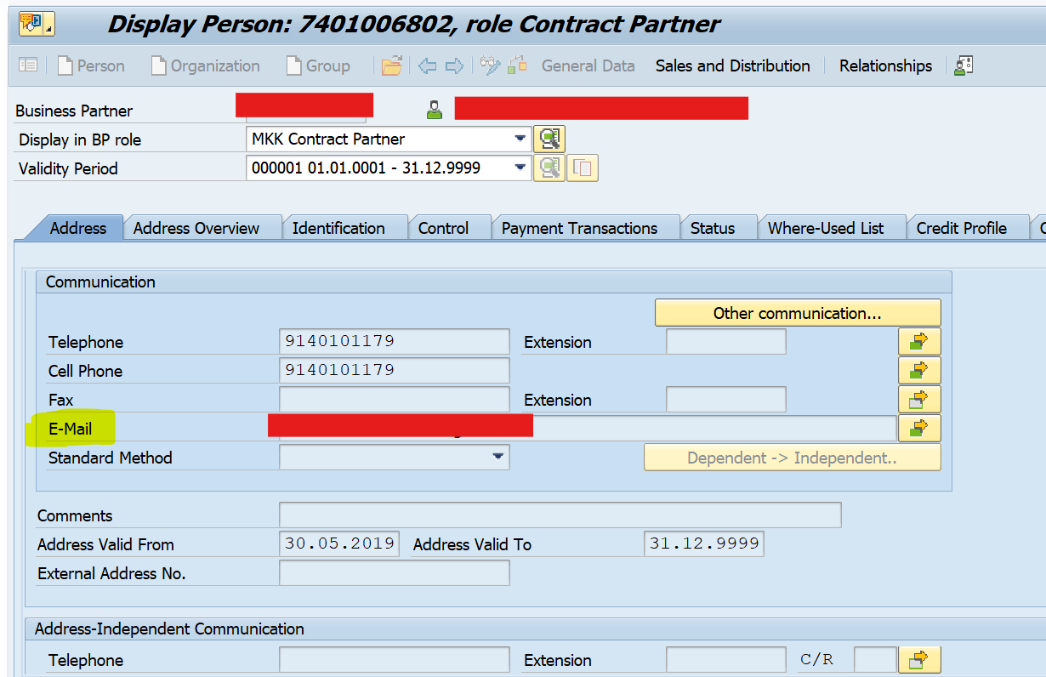
For Reversed Invoices, a new Rebill invoice number would be generated. The new Invoice number will be treated as a fresh Invoice and will sent out email of the printed invoice( rebilled invoice)

Processing Type
As it will be a new program to trigger the email for all eligible printed invoices, this can be used in Individual(Real time) and/or in Batch Mode.
Batch: The Batch Mode is to be scheduled with the fixed Parameters set as Execution able variant.
Real Time (Individual Run): The Alternate option is to trigger it individually and allow selected end users to trigger email from SAP for selected parameters:-
Selection Screen input Fields:-
- Print (Invoice) Document Number Range – [Either this or BP/CA is mandatory]
- Business Partner Number Range - [Either this or Print Invoice Document Number is mandatory]
- Billing Transaction Type (Periodic-01/Interim-02/Move Out-03/Manual-06) – With F4 Help option.
- Reprint Flag – If checked only then printed invoice that needs to be reprinted.
- Email address – If there is an additional Email address that you would like to sent the Bill print along with the address maintained at BP. [Range]

Output Type
The output should display an ALV screen with displaying following items along with the status.
In both the Batch, and the Front end Individual execution, the processing of email, along with ALV screen display will also update a Maintainable Custom table with the following entries:-
- Print (Invoice) Document Number
- Business Partner number – Contract Account
- Billing Transaction Type (Periodic-01/Interim-02/Move Out-03/Manual-06)
- Email sent successfully Text {Editable Field}
- Email sent Flag - (Sent or Error) {Editable Field}

Functional Design

The program needs to be executed whenever there is a need to send out the email to customer with Printed Invoice.
As mentioned earlier, the program can be used as a Batch Program based on Portion that needs to be processed further for sending out the email attachments.
The Real time Individual execution would have a selection screen execution with certain input parameters.
Mandatory field: Either “Invoice Doc” or combination of “Contract Account + Posting Date” or combination of “Portion + Posting date” must be present.
Optional fields: Posting Date, additional Email address, Re-email Flag. MRU value must be specified with posting date on selection screen( if MRU is only source)
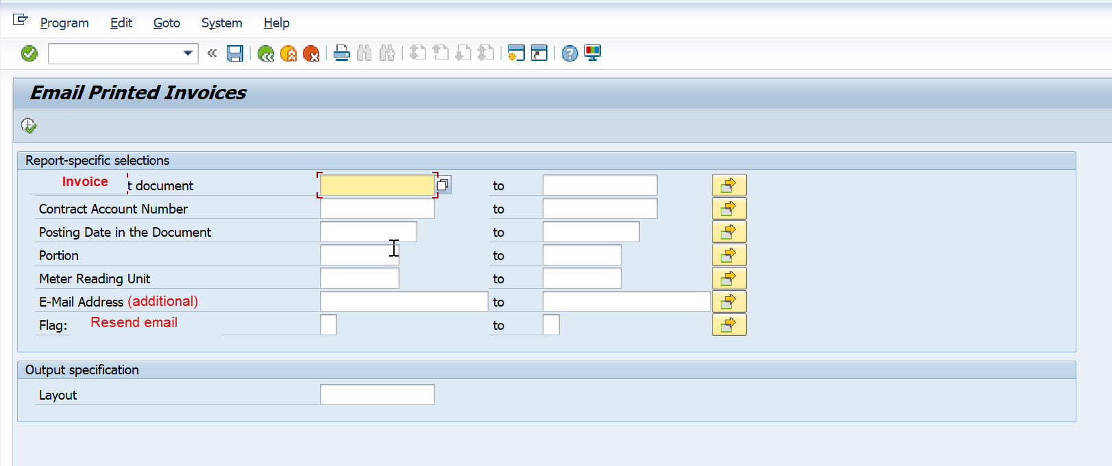
Requirements from Business
- To include MRU in both selection & output
- Instead of Print date, need to provide Posting date on selection screen but Print date should be visible on the output ALV screen in the log table as well
- Remove the check on Billing Transaction type – 01,02,03,06.
- Expecting SAP to support approx. 50,000 emails per day. – SAP need to confirm with the infrastructure team.
Among the above suggestions from Business, it was highlighted that the user will be required to provide a date along with Objects like MRU & Portion as a single MRU could have tens of thousands of invoices and the program would need support from a date range within which it should scan the eligible Invoices.
As mentioned earlier, the selection screen would have the options to provide multiple input values on screen available. To guide the user to provide right combination of the inputs required, we would have clear messaging system in case on invalid or partial input provided on screen
Input screen related error messages: -
- If user doesn’t provide any input on selection screen: “Please Provide Valid Inputs on the input screen”
- If user specify Contract account but no posting date: “It is mandatory to provide Posting date with Contract account on the input screen”
- If user specify Portion but no posting date: “It is mandatory to provide Posting date with Portion on the input screen”
- If user specify MRU but no posting date: “It is mandatory to provide Posting date with the MRU on the input screen”
- If the user specify an Invoice number but the invoice table doesn’t have a print date present(ERDK-DRUKDAT): Invoice is not yet printed.
Once the program is processed, it is expected to update a Customizable Maintenance Table which will be updated by the program for each invoice that are processed against the Date and Time with the user ID ( Individual ID or Batch ID).
The output ALV display would be uneditable as provision to make changes are being provided on the customizable Log table.
There will be a Flag also updated in the custom table calling it a Success or Error.
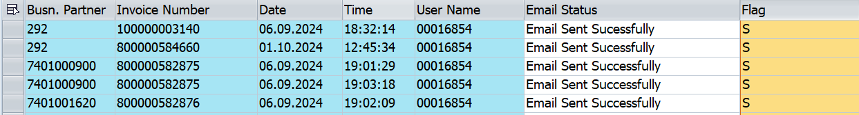
Business Input: Need to include MRU and Invoice original Print Date in the output screen
Contract Account | Invoice Number | MRU | Orig. Print Date | Email Date | Email Time | User name | Email Status | Email status Flag
hkont | opbel | ABLEINH | dats | dats | time | uname | Char1 | Char20

Technical Note: In case MRU is not provided on selection screen, the program should take the Contract Account Number (VKONT) & BUDAT from ERDK table and using value from VKONT, should enter table EVER where EVER-AUSZDAT<=ERDK-BUDAT<=EVER-EINZDAT and get the value of ANLAGE. Once we have ANLAGE, it should use this value to enter ENALH where EANLH-BIS<=ERDK-BUDAT<=EANLH-AB. Get the MRU value from field ABLEINH

As is a standard for all such tables, it will be provided to download an excel of the captured logs. 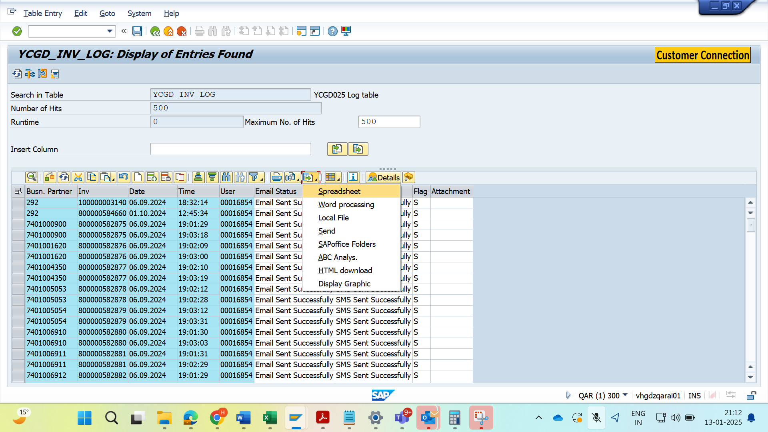

Errored out invoices can be sorted based on the Errored Flag:
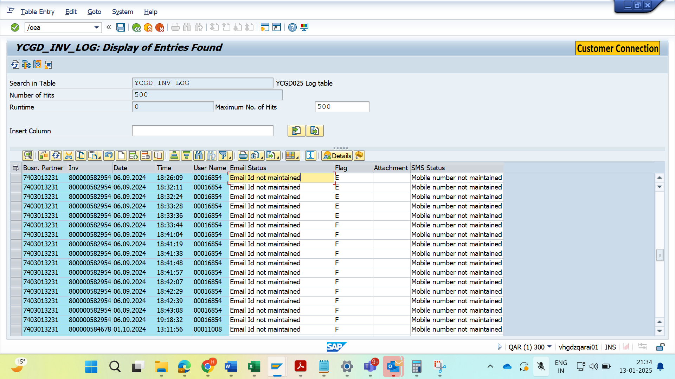
- Email Not Maintained.
- Maintained email address Invalid
- Invoice not Printed yet.
- Email not sent due to untraceable technical reasons.

At the time of technical design finalization, based on appropriate feasibility, best suited Functional Module will be utilized:-
- SO_DOCUMENT_SEND_API1
- SO_NEW_DOCUMENT_ATT_SEND_API1
- WEC_USER_SEND_EMAIL
Note: Maintenance of the custom table will be taken by the business based on various parameters like regulatory requirements, business volume, performance issues, the retention period etc

Security / Authorization Requirements
Authorization requirement where Business defined role for CORE team should have this transaction. This t-code should not be allowed to be executed by any other.

Definition
Not Applicable.

Defined Fields
A couple of field value are expected to have field value checks present for them.
- Email Address validation[BUT020-ADDRNUMBERàADR6-SMTP_ADDR]
  - The address must have a “@” symbol with Prefix on left and Domain on right.
  - Prefix can only contain - letters (a-z), numbers(0 – 999999999), underscores(_), periods(.), and hyphen dashes(-)
  - Domain Allowed characters: letters, numbers, dashes. E.g. “mail-archive”.com
  - The last portion of the domain must be at least two characters after the Dot, for example: .com, .org, .cc
- The Print date must be present on the Invoice [ERDK-DRUCKDAT]
- Contract Account Number, if provided on selection screen [ERDK-VKONT]
- Invoice Number, If Provided on selection screen [ERDK-OPBEL]
- Posting date can be provided on the selection screen [ERDK- BUDAT]
- Meter Reading Unit : The Program will have to first fetch all the Installations(ANLAGE) from Installation Time Slice table( EANLH- ABLEINH) where posting date (BUDAT) falls between (EANLH-AB) and (EANLH-BIS). Now from all Installations under this MRU, enter table EVER to get contract account(VKONT). Use FM = ISU_DB_ERDK_SELECT_VKONT by providing contract account as Input. Now select the OPBEL from ERDK output structure which has same posting date as mentioned by the user on screen.
- Proposed Status table(custom) to be developed – Z_INV_EMAIL_LOG
  - The custom table must have a Flag with indicator
  - The custom table must be updated every time the program is executed.

Program Flow related error messages: -
- If the processed invoice is not found with print date: “Error: Invoice Not yet printed”
- If the associated BP is found without an email address: “Error: Email address not maintained”
- If the email address is found incorrect in basic checks: “Error: Invalid Email address”
- If the program is unable to fetch the stored Print PDF: “Error: Unable to fetch stored PDF”
- If the program has processed data and yet it is unable to trigger email: “Error: Technical Reason, please Reprocess”

Procedure
The correct procedure for this program would be to first identify if the eligible Invoices are already printed by confirming the presence of ERDK- DRUCKDAT field value. If its true, then the process would attempt to get the email address from the associated Business partner. The email address would be verified for basic checks like domain name, presence of “@”, no character other than alphabet, number, hyphen, underscore, period(.) and then proceed to send the email to the address.
Based on the finalization of the approach by Manilla Waters on the PDF storage, further mechanism has to be concluded along with DMS team.
The attached PDF is required to be extracted from the OpenText DMS system which provides an anchor for each Invoice number. This Key is basically utilized by the program to get the PDF maintained and then attached with the email.
It is to be confirmed with Business if the email needs to be sent out using a Batch user or MWC user or want a separate SAP User id only for sending the emails.
Technical Note: The API to send out the email using different userid: SO_NEW_DOCUMENT_ATT_SEND_API1

Process Flow Diagram
The flow depicts how an individual invoice will be processed by the program.
In case of error generated, the mass program would continue for the next Invoice number with the same logic from the starting.
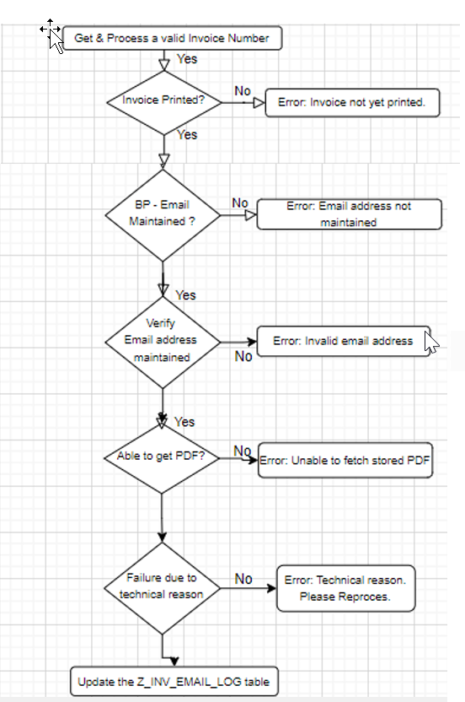

Technical Note: Open Text team to conculde logic for error : Unable to get the stored pdf

SAP Transaction
Custom Transaction : Z_EMAIL_INVOICE_PDF

Form Layout
Not Applicable

Printer Requirements
Not Required.

Legal Requirements
Not Applicable

Form Fields
Not Applicable

Main Heading
Not Applicable

Sub Heading
Not Applicable

Totaling
Not Applicable

Sorting
Not Applicable

Page Breaks
Not Applicable

Stationery
Not Applicable

Logo(s)
Not Applicable
Invoice will go along with provided logo but the email will not have any separate logo.

Bar Coding Requirements
Not Applicable - TBD
Need to confirm with business team if a bar code requirement is there, if yes, what logic is required to be followed?
BarCode will be placed in the printed copy ( to be provided by MWC business team) but Email will not have any BarCode requirement.

Email Requirements
EMAIL Header & Text Body:-
An email functionality will be provided where each bill will be processed as an attachment to the email address maintained at the Business partner communication section.
In case the email address is not maintained at the BP level, the email will cannot be sent.
It is to be confirmed with business, if a reprint is requested for a particular Invoice, should is also trigger the email once again as the customer already has a copy of that Invoice. Please note here that reprinting is different from reverse rebill where a new invoice number is generated and that does not qualify as reprint.
A simple maintenance table with email sent confirmation can be maintained only till the SAP SOST email administrative processing. Any error outside SAP during email communication is not technically possible to be captured in the SAP System and outside the preview of this document.
Email Subject: Invoice Attachment for Contract Account value.
Email Text: -----To Be Confirmed with Business Team, Sample Text below:-
Dear Customer,
Greetings from Manilla Water Company!
Your Water Consumption Bill for CA No:' Contract Account number 'has been generated and is attached herewith.
Due amount is Rs.' PHP peso 'and due date is' DD/MM/YYYY
Thanking you,
Manila Water Company

Existing Sample Forms
- Not Applicable

Assumptions in Functional Design
- All external mechanism (outside SAP) to receive and further send the email are in place with MWC Architecture.

Open Issues in Functional Design
Below Issues are yet to be resolved: -
- Open Text DMS system mechanism to be finalized – To Be Confirmed later with OpenText DMS team.
- Maintenance/Archiving of Customized Log Table. – Confirmed by business to Keep the log table Customizable by SM30.
- Email Body Text to be confirmed by MWC. – MWC will confirm with the “communications” team and revert with the approved text.

Business Test Conditions

Scenario # | Input Selection Criteria | Expected Result
1 | Attempt Email for a valid invoice without email address maintained | Error captured in log table. Error: Email address not maintained.
2 | Attempt Email for a valid invoice which is not printed yet? | Error captured in log table. Error: Invoice not yet printed.
3 | Attempt Email for a valid invoice which is maintained with an invalid email address | Error captured in log table. Error: Invalid email address maintained.
4 | Attempt Email for a valid invoice for which program is able to extract stored PDF | Error captured in log table. Error: Invalid email address maintained.
5 | Attempt Email for a valid invoice which is faced an untraceable error | Error captured in log table. Error: Failure due to other reasons. Please Reprocess.
6 | Attempt email which has all valid parameters maintained. | Email sent successfully.

Related Documentation
2205904 - Error when Repeat send email - SAP for Me

